Author Guidelines DFI Journal
Anne Lemnitzer* and Tim Siegel

Abstract
This page demonstrates the format of the front page of your manuscript. The abstract of your manuscript should not be longer than 220 words and include no references, figures, and equations. The DFI Journal publishes practice-oriented, high-quality papers related to, but not limited to deep foundation engineering. Any papers within the scope of interest of DFI’s geo-professional community as well as areas covered by DFI technical committees are welcome. Each paper is independently peer-reviewed. Opinions and findings expressed in all technical publications are those of the individual authors and do not necessarily represent the views of DFI. All submissions to the Journal must be free of evident commercialism or private interest but must not obscure proper names when they are required for an understanding of the subject matter.

Keywords: separate keywords by comma, do not use more than 15 individual words, all keywords should be lower case (e.g., foundation testing, pile analyses)

Introduction
The Deep Foundations Institute offers these recommendations for preparation of a technical paper as a means of providing guidance to authors preparing papers for publication in the DFI Journal. Following these recommendations will ensure a reasonable degree of uniformity of the papers received for publication. The authors are not required to format their papers to the final “in-print” format, but rather follow the general format outlined in this guidance document. This is particularly important for figures and equations, as well as for references.

Submissions
Submissions should be made using DFI’s Editorial Manager which can be accessed at https://www.editorialmanager.com/dfi/. This requires the Corresponding Author to decide on the type of submission, before entering its title and authorship. Authors are invited to upload the main text (mandatory), and any figures, and tables associated with the paper. A cover letter can be included if desired. During the first submission, each author is permitted to submit a manuscript with embedded Figures. Upon submitting a revision, authors must submit independent, single, high-quality figure files in tiff, jpeg or pdf format (see figure requirements).

Areas of Interest for Publication
The areas of interest for publication in the DFI Journal include but are not limited to deep foundation engineering, including different piling systems (such as drilled shafts, driven piles, etc.), load testing, case studies, ground improvement, soil nailing and anchors, foundation elements for landslide and slope stabilization, earth retention systems and structures, BIM and digitalization, energy foundations, seismic issues of foundation engineering, sustainability, seepage control, design standards, codes, and contracts, tunneling, other areas of foundation design, innovative construction technologies, material research, quality control, quality assurance, and non-destructive testing and evaluation, or historical evolution of deep foundations, etc.

Types of Papers Published by the Journal
The following types of papers are included in DFI Journals. Other paper types, as well as proposed special issues, should be discussed with the Journal editors and are most welcome in addition to the common paper types outlined below:

Research Papers
Technical Papers, also referred to as research papers, present original findings from an investigation and should not have been previously published elsewhere. Research papers should be around 5,000 (max 7,500) words in length plus Figures and Tables.

Technical Notes
Technical notes seek the presentation of novel findings, recent and original research, as well as emerging ideas and designs for quicker release to the professional community. The manuscript text of technical notes should not exceed 2,000 words and four figures and / or tables. This word count excludes the abstract, keywords, acknowledgements, and references.

State-of-the-Art Reviews
Review papers examine the current position of a subject in a critical and comprehensive manner. The review should be well referenced. The typical length of a review paper is 5,000 words plus figures and tables. A State-of-the-Art Review should include an extensive literature research of the most recent and relevant studies as well as a perspective on the history of practice and the importance of the field.

Case Studies
Case studies are practice-oriented papers that describe innovative techniques to solving a problem. The case study should have broad implications and knowledge that can be applied towards other scenarios or designs. Case studies should not exceed 7,500 words plus figures and tables. Case studies do not need to contain unpublished research findings but should describe a method or application of existing or new techniques within a specific scenario.

Discussions
A discussion allows the reader of an article to respond and comment on a previously published paper. The discussion should be technical, fair and free of personal prejudice or insult. The discussions will be reviewed by the editorial board only. The authors of the paper being discussed are given the right to reply. A discussion should not be more than 3000 words plus four figures and / or tables. Exceptions may be requested from the Editors.

Forum Papers
Forum papers follow the general guidance of Technical Notes (2000 words and up to 4 figures and tables); however, exceptions will be granted by the Editors.
Book Reviews
A book review should contain between 1000-2000 words and may include up to three figures or tables (if needed).

Word Count
If the paper exceeds the recommended word counts described above, authors are recommended to discuss the submission directly with the Editors-in-Chief of the Journal.
Structure and Format of the Manuscript
When preparing a manuscript, the structure exemplarily outlined in this manuscript should be followed.

General Structure:
- Paper Title
- Authors – Full names separated by commas; Corresponding author identified with an asterisk. One corresponding author identified for each manuscript. The corresponding author does not need to be the first author of the paper.
- Keywords
- Abstract
- Author Footnotes – Position, Institution/Company, City, State, Country (see sample 1st page)
- Corresponding Author’s email (with no limitations/termination)
- Manuscript Text (Introduction, Lit Review, Research Presentation, Discussion, Summary/Conclusions)
- Acknowledgements
- References

Format Specifications
- Page Size: 8.5 x 11
- Margins: .75 on all sides
- File Type: .docx or .rtf
- Fonts: Times Roman or Arial
- Font Sizes: Subheads: 14 pt. Bold
    - Secondary subheads: 12 pt. Bold Italic
    - Text: 12 pt. (Arial can be 11 pt.)
    - Captions for figures: 9 pt. Bold (no periods unless complete sentence)
- Line Spacing: 1.5 lines
- No additional space between paragraphs, and after headings.

Headings
Use headings to separate sections of the paper. All headings should be in bold type letters. Primary Level headings should start with capital letters. Second Level heading should be italicized and capitalized (first letter in upper case and following letters in lower case). If a second level heading follows directly below a primary headline, no blank line is necessary between the two. Main sections headings should have size 14 and be bold (as used in this document), all subheadings shall be bold, italics and written in the main text font size (e.g., 12). Each manuscript page should contain page numbers. The use of line numbers is optional.
Abstract
The abstract should be written in one paragraph and contain no more than 220 words. It should state the objective of the paper and report the results and main conclusions resulting from the work. The abstract should not include references, figures or equations.
Keywords
Keywords should be specific and relevant for the content of the manuscript. The authors should seek to use keywords that can be easily found during an online search. Keywords can consist of word groups (e.g., laterally loaded piles, soil structure interaction) but should not have more than 15 individual words in total.
Figures
Graphics, such as graphs, charts, tables, figures, photos, etc. may be embedded within the document to show preference of placement within text as well as to ease the review process. In addition, each figure must be submitted as a separate, high-resolution jpeg or tiff file through the editorial manager. The desired resolution for figures is 300 dpi at 100% actual print size or larger. Do not embed captions or lengthy text in the figure. In general, figures will be sized to single column width (80mm) or page width (168mm). Ensure the labelling on figures will be legible when reduced to final size.
Ideally, figures should present findings in both unit systems (SI and USC). The use of US customary units only is not permitted. Figure 1 below demonstrates the use of the dual unit system within a figure. Axis labels should be precise and indicate the unit of the values displayed in parenthesis or brackets.
If a figure is reproduced or adapted from other work, this must be made clear in the caption and a reference cited, together with any other acknowledgements requested by the copyright holder. See the permissions section for further information.
Figures should be prepared in a professional and scientific manner. We recommend the use of programs such as Grapher, Matlab, Sigmaplot, or similar. We strongly discourage the use of Excel for figures and graphs.
Figure Placement, Numbering and Captions
Provide one blank line above a figure and a blank line below the figure caption. Figures should be placed in the text after and in immediate connection to where they are first mentioned. Number the figures starting from "Figure 1." When referring to a figure in the text, write "Figure #." When starting a sentence with the reference to a figure, do not start the sentence with "Fig. #," always, spell out "Figure." When referring to several figures, write Figures # - ##. The figure captions should be placed below the figure; it should be left aligned, bold and in 9 pt text size. The figure caption should be short and not duplicate the information given in the text.
Figure Colors, Weights, Line Styles, Legends and Labels
Data presented in the figure should be clearly distinguishable by line color, line weight and/or symbols. In addition to using different line colors, different line styles and thicknesses are to be used in combination with the above. Graphs with colored lines and keys, contour maps, model outputs, etc. may not reproduce adequately if converted directly to greyscale or printed in black and white. Red and blue convert to similar grey levels and will not be distinguishable. Figures of this type must be reformatted (e.g., using symbols or dotted/broken lines to distinguish curves) or labelled to ensure clarity. Legends should include all data presented in the graph and have sufficiently large font sizes. All line weights should be thicker than the axis weights used in the graph. Examples for figures using the dual unit axis style as well as part (a) and part (b) are shown in Figures 1 and 2.
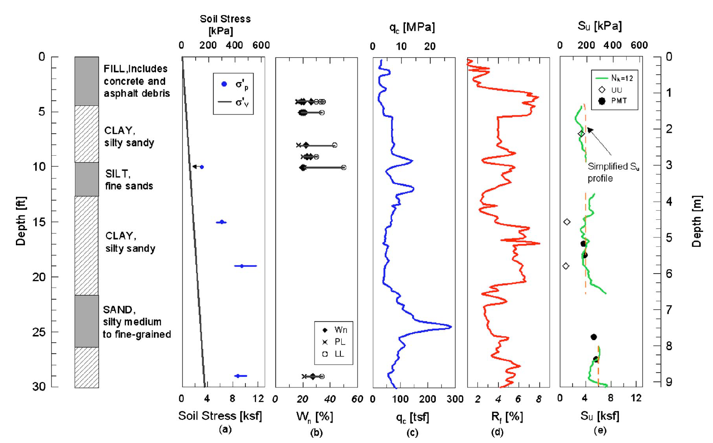
Figure 1. Soil stratigraphy at the test site (Figure Example)
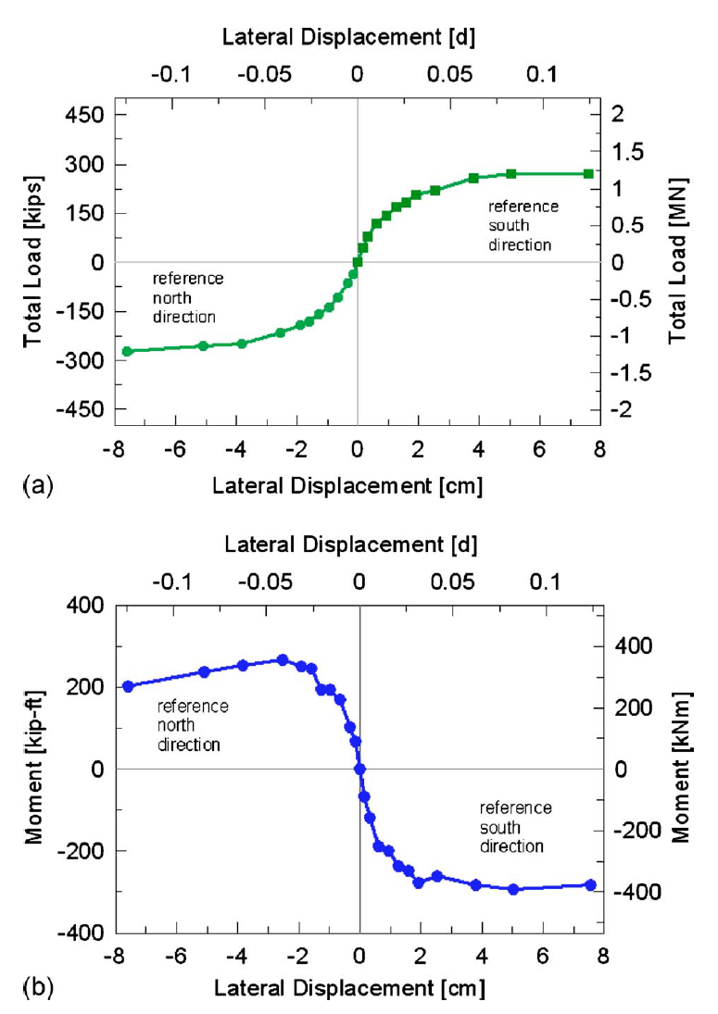
Figure 2. (a) Load -displacement curve, and (b) moment vs. displacement curve for test pile

Tables
Please submit tables as editable text and not as images. Tables can be placed either next to the relevant text in the article, or on separate page(s) at the end. Number tables consecutively in accordance with their appearance in the text and place any table notes below the table body. Be sparing in the use of tables and ensure that the data presented in them does not duplicate results described elsewhere in the article. The table caption should be placed above each table and should be a short descriptive summary of the table content. All columns must have a heading. Each table should have only one set of column headings at the top of the table. Using additional column headings within the body of the table should be avoided. Do not use vertical rules for any table. Photographs, figures, or other any graphic elements are not permitted in tables. Equations should be used sparingly in tables. An example can be found in Table 1.

Table 1. Pile length estimates – Table taken from Boeckman (2019) for demonstration
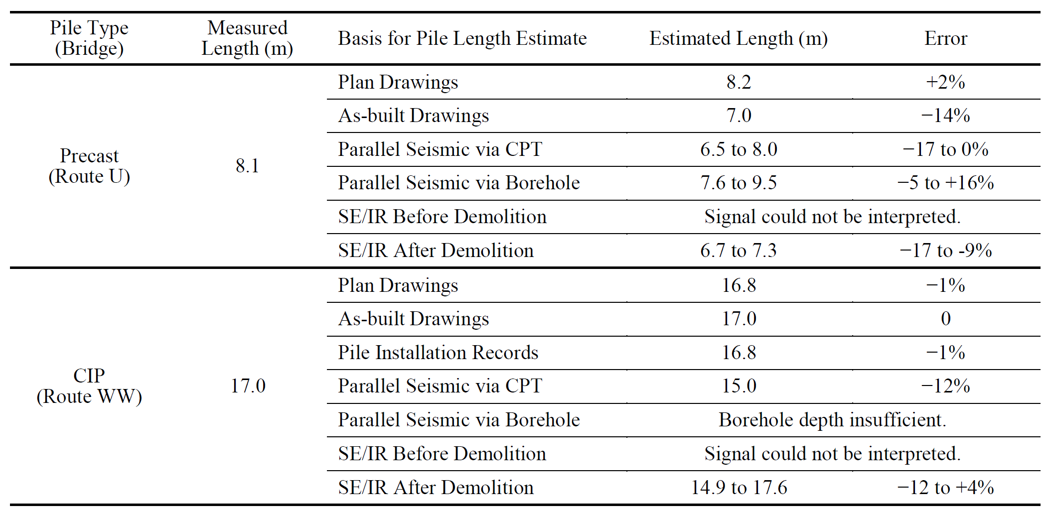

Equations
For maximum clarity, equations should be written with the reference number in parenthesis, right justified as shown below on the same line as the equation. The equation legend is then written below the equation. When preparing your manuscript in Word, use Microsoft’s equation editor, by clicking “insert” “Equation” and typing your equation into the text using the options provided within the Microsoft equation editor. Do not embed equations as files (e.g., jpeg or pdfs).
(1)
Where Q = applied load, δ = movement, C₁ = slope of the straight line in the √δ/q versus movement diagram, and C₂ = y-intercept of the straight line in the √δ/q versus movement diagram.

Units
All units shall be in the SI-system. If the author wishes to present findings in US customary units, the SI unit equivalent values should be presented as the primary unit with the comparable US customary unit in parenthesis (in text), or in a second axis (for Figures). It is recommended that figures have dual axis as shown in Figures 1 and 2. Information about SI units can be found from NIST at: physics.nist.gov/cuu/Units/index.html. Units should be abbreviated when appearing in the text. There should be no space between the value and the unit; e.g., 1.2m; 34deg; 34°; 1.0m (3ft), 40MPa.

Definitions and Symbols
All abbreviations (e.g., FHWA, SSI, DFI) must be defined during their first occurrence in the text. All special characters and sub/superscripts should be clearly typed. The use italics for all variables, including variables that are subscript and superscript is recommended. Similarly, all symbols should be defined at their first mention in the paper. Symbols should be typed using the Microsoft equation editor (like equations). Small in text equations such as $0.2xP_{ult}$ should also be typed in the equation editor. The multiplication sign should be “x”, not “*”.

Summary and Conclusions
All manuscripts should contain a section discussing the result presented and a summary of the findings and conclusions reached. The Summary or Conclusion presents, but only very briefly, the background, objectives, and scope of the work presented in the paper and emphasizes the results and the conclusions from the work. No new information should be introduced here. This section should describe the lessons learned and its applicability and relevance to readers in other countries and other related practices. It should summarize the main findings as specifically as possible, i.e., do not write “This paper presents the results from field tests comparing polymorganic piles with monogamic piles and comments on the economics of the new piles.” Such a sentence is only descriptive and provides very little useful information. Instead, concentrate on the factual information and give specifics, such as: “Results from full-scale static loading tests to failure loads of about 5,000 KN showed that the stiffness of polymorganic piles was four times smaller than that of monogamic piles.” Equations and figures are not permitted in the Summary section. References are to be used sparingly.

Acknowledgments
The acknowledgements should list individuals and institutions who have contributed to the work. If applicable, detailed information about the funding bodies shall be listed. This includes a detailed list of each funding agency that supported the work described in the manuscript and the respective grant/award number. In-kind contribution shall also be acknowledged. The acknowledgements may also include copyright information that is too extensive to include elsewhere, and other information (such as the fact that the paper is based on a lecture or conference presentation).

References
General Format and In-text References
The DFI Journal uses the author-date method for references placed in-text. Hereby the citation reads as the last names of the authors, then the year (e.g., (Lemnitzer, 2004), or (Lemnitzer and Siegel, 2004)). If there are more than 2 authors in the work to be referenced in-text, the format should be as follows (Lemnitzer et al., 2004). Please note that the “et al.” should be italicized. All references included in the reference list must be cited in the manuscript text. Unpublished results and personal communications are not recommended; they may be mentioned in the text but should not be listed in the reference list. When reference is made to more than one paper by the same author(s) published during the same year, denote the references by 1984a, 1984b, etc., with "a", "b", etc. determined by alphabetical order from the first word in the title.
The reference list is to be formatted in APA style. Examples of the APA style format for various types of publications can be found below, as well as in the following links.
- https://owl.purdue.edu/owl/research_and_citation/apa_style/apa_style_introduction.html
- https://apastyle.apa.org/style-grammar-guidelines/references/examples
- https://libguides.nus.edu.sg/c.php?g=145716&p=954481

Please note that the APA style italicizes different elements of the reference. While for journal articles, the journal name is in italics, for books – the title is in italics. Common examples are provided below. They are a compilation of various resources from the web to ease the formatting for Journal authors. If a journal article has a DOI, please include the DOI in the reference. The DOI should be placed at the end of the reference.

List of References (placed at the end of the manuscript)

The reference list should follow the APA style as explained above. List authors’ last names, followed by initials, and place the year of the publication in parenthesis. Examples for singles vs. multiple authors are presented below. These apply to all types of references (e.g., journals, magazines, conference papers). Always use the last name, followed by the initials. Two authors should be separated using the ampersand instead of “and” (see example). For three and more authors, list all last names and initials, use commas to separate authors names and add the last author’s name with an ampersand (see Example 3):

Example 1 single author:
Berndt, T. J. (2002). Friendship quality and social development. Current Directions in Psychological Science, 11, 7-10.

Example 2, two authors:
Wegener, D. T., & Petty, R. E. (1994). Mood management across affective states: The hedonic contingency hypothesis. Journal of Personality and Social Psychology, 66, 1034-1048.

Example 3, three and more authors:
Kernis, M. H., Cornell, D. P., Sun, C. R., Berry, A., Harlow, T., & Bach, J. S. (1993). There's more to self-esteem than whether it is high or low: The importance of stability of self-esteem. Journal of Personality and Social Psychology, 65, 1190-1204.

Example References for Different Publication Types

JOURNAL ARTICLES
Example for Journal article with DOI
Herbst-Damm, K. L., & Kulik, J. A. (2005). Volunteer support, marital status, and the survival times of terminally ill patients. Health Psychology, 24, 225-229. doi:10.1037/0278-6133.24.2.225

Examples for Journal articles without DOI
Guo, W. D., Chow, Y. K., & Randolph, M. F. (2007). Torsional piles in two-layered nonhomogeneous soil. International Journal of Geomechanics, 7(6), 410–422.
Chen, S. L., Kong, L. G., & Zhang, L. M. (2016). Analysis of pile groups subjected to torsional loading. Computers and Geotechnics, 71, 115–123.
Parker, R., & Fox, K. M. (2010). Postnatal depression: A meta-analysis. Australian and New Zealand Journal of Psychiatry, 29(3), 272-285.
Example for Electronic Journals
Jones, T. J., & Fields, N. (2003). Emotional quotient and personality. E-Journal of Applied Psychology, 2(2), 38-45. Retrieved from http://ejournalappliedpsyc/index.php/ejap
MAGAZINE ARTICLES (IN PRINT)
Rothbart, D. (2008, October). How I caught up with dad. Men's Health, 108-113.

MAGAZINE ARTICLES (ONLINE)
Folger, T. Higgs: What causes the weight of the world." Discover Magazine. Retrieved from http://discovermagazine.com

Bradley, K. (2012, December). The trick to tomatoes. Green Lifestyle Magazine. Retrieved from http://www.gmagazinecom.au/features/3530/trick-tomatoes

CONFERENCE PAPERS
Conference Papers in Proceedings Published Online:
Herculano-Houzel, S., Collins, C. E., Wong, P., & Kaas, J. H. (2008). The basic nonuniformity of the cerebral cortex. Proceedings of the National Academy of Sciences, USA, 105, 12593-12598. doi:10.1073/pnas.0805417105

Anacleto-Lupianez, S., Herrera, L., & Lemnitzer, A. (2017). Large-scale testing of FRP strengthened RC-SMRF T-Beams with rectangular web openings. Proceedings 16th World Conference of Earthquake Engineering, Santiago, Chile. Retrieved from http://wcee.nicee.org/wcee/article/16WCEE/WCEE2017-4578.pdf

Conference papers published in proceedings (print proceedings):
Author, A., & Author, B. (Year, Month date). Title of session [Paper presentation]. In A. Editor, & B. Editor. Title of Published Proceedings. Title of Conference: Subtitle of Conference, Location (inclusive page numbers). Publisher.

Tiwari, B., Pradel, D., & Ajmera, B. (2018). Equations to calculate undrained shear strength of lacustrine soil deposit with Swedish cone equipment. In A. Stuedlein, A. Lemnitzer & M. Suleiman (Eds.), IFCEE 2018:Advances in Feomaterial Modeling and Site Characterization. Internation Foundation Congress and Equipment Expo, Orlando, Florida, 32-42. ASCE, Virgina, USA

Katz, I., Gabayan, K., & Aghajan, H. (2007). A multi-touch surface using multiple cameras. In J. Blanc-Talon, W. Philips, D. Popescu, & P. Scheunders (Eds.), Lecture Notes in Computer Science: Vol. 4678. Advanced Concepts for Intelligent Vision Systems (pp. 97-108). Berlin, Germany: Springer-Verlag. doi:10.1007/978-3-540-74607-2_9

BOOKS (PRINT AND ELECTRONIC)
General Formats acceptable in APA
Author, A. A. (1967). Title of work. Location: Publisher.
Author, A. A., & Author, B. B. (1997). Title of work. Retrieved from http://www.xxxxxxx
Author, A. A. (2006). Title of work: Subtitle continues. doi:xxxxx
Editor, A. A. (Ed.). (1996). Title of work. Location: Publisher.

Examples:
Lindberg, C. A. (1967). Gender and depression. Massachusetts: Brill.

Tang, G., & Elliot, B. T. (1997). Organization and psychology. Retrieved from http://taylorfrancis.com.uk

Jackson, J. (2006). Brain cognition: Applications and trend. doi:10.10345/10762-011
Townsen, A. C. (Ed.). (1996). The encyclopedia of pain. Oxford: Oxford University Press.

GOVERNMENT REPORTS (issued through a federal/state entity)
U.S. Department of Health and Human Services, National Institutes of Health, National Cancer Institute. (2016). Taking part in cancer treatment research studies (Publication No. 16-6249). Retrieved from https://www.cancer.gov/publications/patient-education/CRS.pdf
AASHTO (American Association of State Highway and Transportation Officials) (2014). Guide Specifications for LRFD Seismic Bridge Design, 2nd Ed., 2014 interim. Publication No. FHWA-NHI-15-004. AASHTO, Washington, D.C.

TECHNICAL REPORTS (cited by the author)
Ebert, S. A., & Davey, C. M. (2013). The contribution of microfinance institutions to poverty reduction in Tanzania (Research Report No.63). Retrieved from Research on Poverty Alleviation website: http://www.repoa.or.tz /documents/Publications/Reports/63.pdf

Yen, W. P., G. Chen, I. Buckle, T. Allen, D. Alzamora, J. Ger, and J. G. Arias. (2011). Post-earthquake reconnaissance report on transportation infrastructure: Impact of the February 7, 2010, offshore Maule earth- quake in Chile. Rep. No. FWWA-HRT-11-030. Washington, DC: Federal Highway Administration.

Brown, D.A., Turner, J.P., and Castelli, R.J. (2010). Drilled Shafts: Construction Procedures and LRFD Design Methods. Publication FHWA-NHI-10-016, Washington, DC: Federal Highway Administration.

CITING A WEBSITE
Mitchell, J.A. (2017, May 21). How and when to reference. Retrieved from https://www.howandwhentoreference.com.

Publication Ethics
A detailed guide on the Journal’s publication ethics and code of conduct can be accessed on the Journal website. Upon submitting a manuscript into the Editorial Manager, the Journal assumes that all authors are familiar with the publication ethics of the Journal and take responsibility in reviewing and following the Journal’s ethics guidelines.

Digital Object Identifier
The Digital Object Identifier (DOI) is a unique identifier assigned to a document by the publisher and registered with CrossRef. The assigned DOI never changes and therefore is the ideal way to cite and link to electronic documents. DOIs are particularly helpful for “preprint” articles which can be cited without having received full bibliographic information. Each manuscript submitted to the DFI journal will receive a DOI. DOI’s are also recommended to be included in all references wherever available.
Language
DFI recommends that all non-native English-speaking authors ask a native English speaker or professional language-editing service to review their manuscript before submission. This is not mandatory but will help ensure that journal editors and reviewers fully understand the academic content of the article. The only accepted language for any manuscript submitted to the DFI Journal is English.
Review
Authors can make suggestions on which editor they would like to handle their manuscript at the time of submission. Suggestions for reviewers with justification of their qualification can be made through the editorial manager. Review results are directly reported to the authors through the Editors of the Journal. Review guidelines are available on DFI’s Journal webpage.

Proofs
Following acceptance of the paper, proofs will be supplied by email to the corresponding author. Proofs will be supplied for checking and making essential typographical corrections only, not for general revision, alteration, or changes to illustrations. Revised proofs will not be supplied to authors. Authors should pay attention to numerical data and equations. Significant changes to the article at proof stage will only be considered in exceptional circumstances and at the editor’s discretion. Authors may be asked to bear the cost of excessive changes, other than those caused by typesetting errors.

Position, Affiliation/Institution/Company, Full Mailing Address, City, Zip Code, Country, email_{(optional)}
Co-editor in Chief DFI Journal, Deep Foundation Institute, 123 XXX Street, Sequatchie, TN, 65zx5, USA, email_{(opt)} *Corresponding author: alemnitz@uci.edu (or tim@dba.world)

